

Internet of things lab ASSIGNMENT

Course code: CSE-402

Submitted to:

Ayanava Paul

Lecturer, UITS



Submitted By:

Md. Shakibul Islam Ramim

ID: 2125051063

Batch: CSE-50

Section: 7B1

Email: 2125051063@uits.edu.bd

## Problem 1: Gas Sensor

## Problem statement:

Take input from a gas sensor. Show the sensor value on LCD and serial monitor.  
Based on the sensor value, you have to turn on 3 LEDs.  
Conditions If the sensor value is less than 100, turn on green led  
If the value is Between 100 and 200, turn yellow led  
If it is greater than 200, turn on red led.

## Circuit Figure:

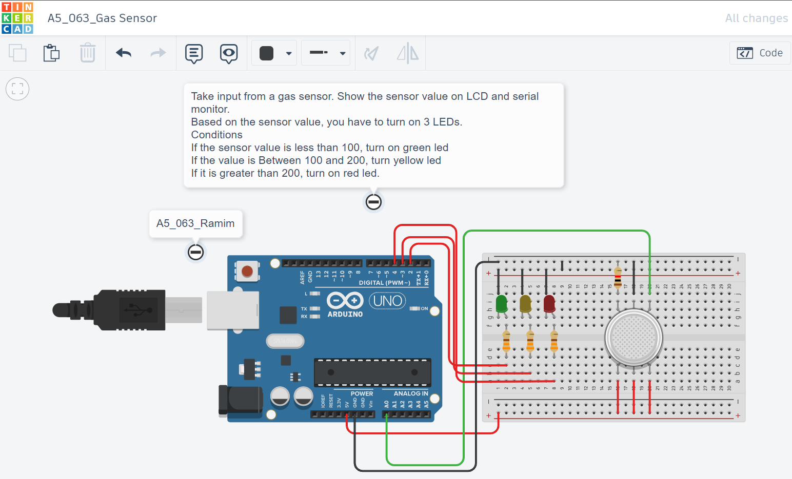

## Code:

// C++ code

//

void setup()

{

pinMode(A0, INPUT);

pinMode(2, OUTPUT);

pinMode(3, OUTPUT);

pinMode(4, OUTPUT);

Serial.begin(9600);

}

void loop()

{

digitalWrite(2, LOW);

digitalWrite(3, LOW);

digitalWrite(4, LOW);

delay(1000);

int gas_sensor_value=analogRead(A0);

Serial.println(gas_sensor_value);

if(gas_sensor_value < 100){

digitalWrite(2, HIGH);

}else if(gas_sensor_value < 200){

digitalWrite(3, HIGH);

}else{

digitalWrite(4, HIGH);

}

delay(1000);

}

## Problem 2: Control a servo motor with potentiometer

### Circuit Figure:

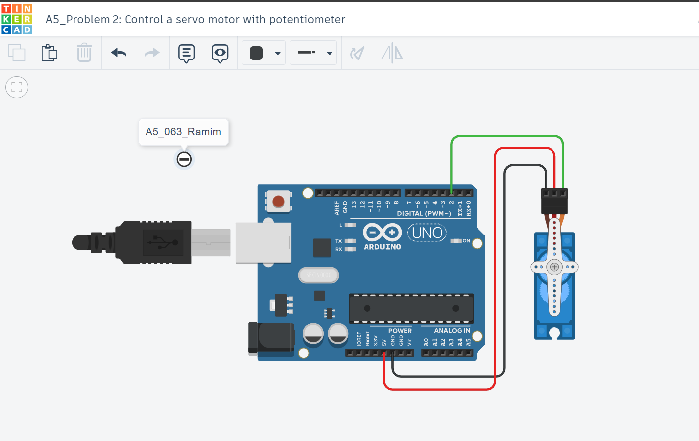

### Code:

#include <Servo.h>

Servo s;

void setup()

{

s.attach(2);

}

void loop()

{

for(int i=0; i<=180;i+=10){

s.write(i);

delay(100);

}

delay(1000);

for(int i=180; i>=0; i-=10){

s.write(i);

delay(100);

}

delay(1000);

}

## Problem 3: Control the brightness of a light bulb with potentiometer

## Circuit Figure:

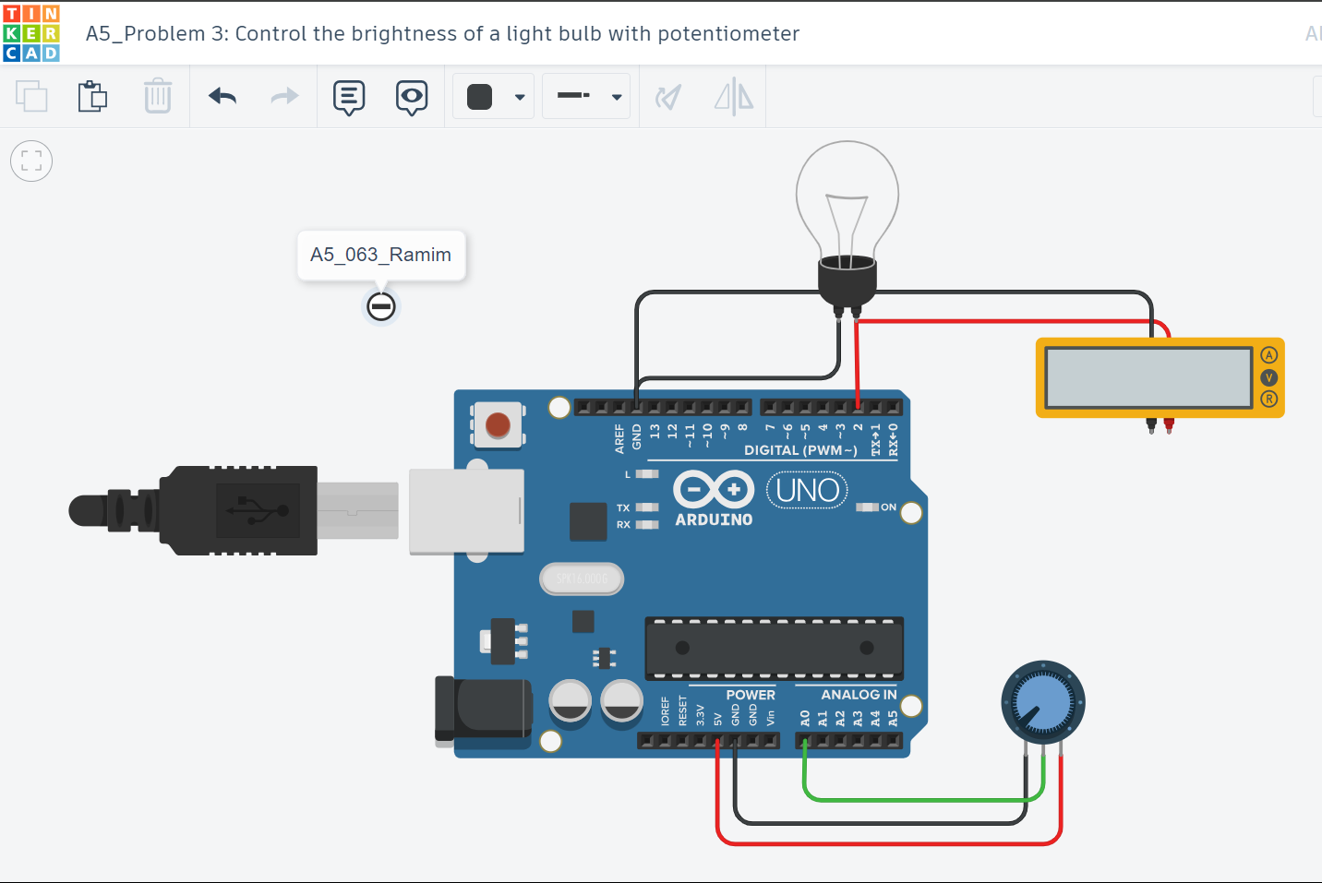

## Code:

// C++ code

//

void setup()

{

pinMode(2, OUTPUT);

pinMode(A0, INPUT);

}

void loop()

{

float sensor_value = analogRead(A0);

float output_value=map(sensor_value,0,1023,0,255);

analogWrite(2,output_value);

}

The End